DELACOMBE PRIMARY SCHOOL
CANTEEN (Thursday and Friday)
MENU TERM 2
2017
Everyday Lunch Menu
Vegemite and cheese scroll $2.50
Bacon and cheese scroll $2.50
Nachos
Nachos with cheese, salsa and sour cream $4.00
PIZZA, PASTA
Pizza – Premade Base
All pizzas have a tomato base and light cheese
Cheese $3.00
Ham $3.20
Ham and pineapple $3.50
Chicken $3.20
Chicken and pineapple $3.50
Pasta
Spaghetti Bolognaise - Homemade $4.00
Tuna Macaroni Bake – Homemade $4.00
Cheese Macaroni Bake – Homemade $3.50
Lasagne - Homemade $4.00
Add 50c for parmesan
Everyday extras
Fried Rice with Bacon - Homemade $3.50 GF
Chicken Nugget .90c
Chicken Nuggets $1.40 GF
Dim Sims .90c

SNACKS
Cinnamon donuts $1.00
Mini muffins .70c
Popcorn .80c
Frozen yogurt $1.40
Jelly $1.20
Frozen fruit icy-pole $1.20
BURGERS and more
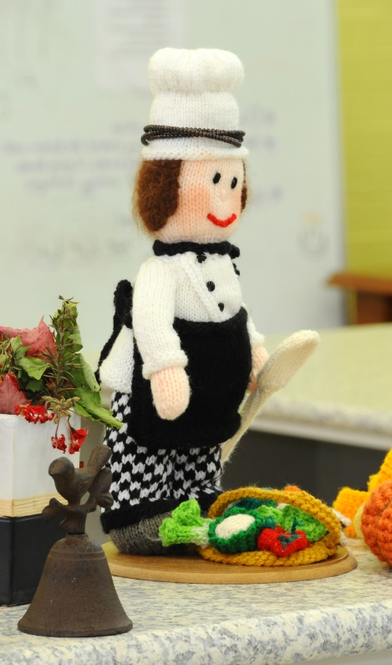
Chicken Schnitzel Burger $4.00
Chicken and Gravy Rolls $4.50
Beef Burger $4.00
Party Pies .90c
Hot Dogs $3.00
Large Sausage Rolls $2.00
Pasties $3.00
Pies $3.00
Gems & Sauce $3.00
DRINKS
Chocolate or strawberry milk $1.50
Tropical, orange or apple fruit $1.50
Hot Milo $1.50

To order please write your child’s name and grade on a PAPER BAG. Total the price and where possible place the correct money in the bag. If you have more than one child ordering their lunch please ensure they use separate bags. Lunch orders need to be in at the beginning of the day.

